**EXPERIMENT – 3**

|  |
| --- |
| **Name: Rahul Maurya**  **UID: 20BCS7260**  **Class: 807 A** |

**AIM:** - Procedure to type a word and apply the effects shadow emboss using Photopea.

**Hardware Requirements: -** Minimum 384MB RAM, 100 GB hard Disk, processor with 2.1 MHz

**Software Requirements: -** Photopea

**Tools Used: -** Type Tool, Bevel and Emboss, Emboss option.

**Step 1:**  Create the new project and set the dimensions according to the requirement.

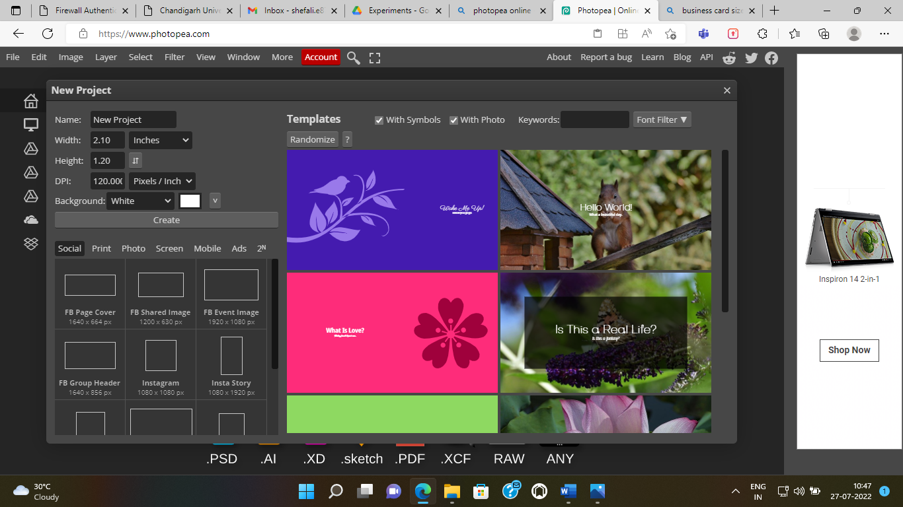

**Step 2: Select the text button and type any word.**

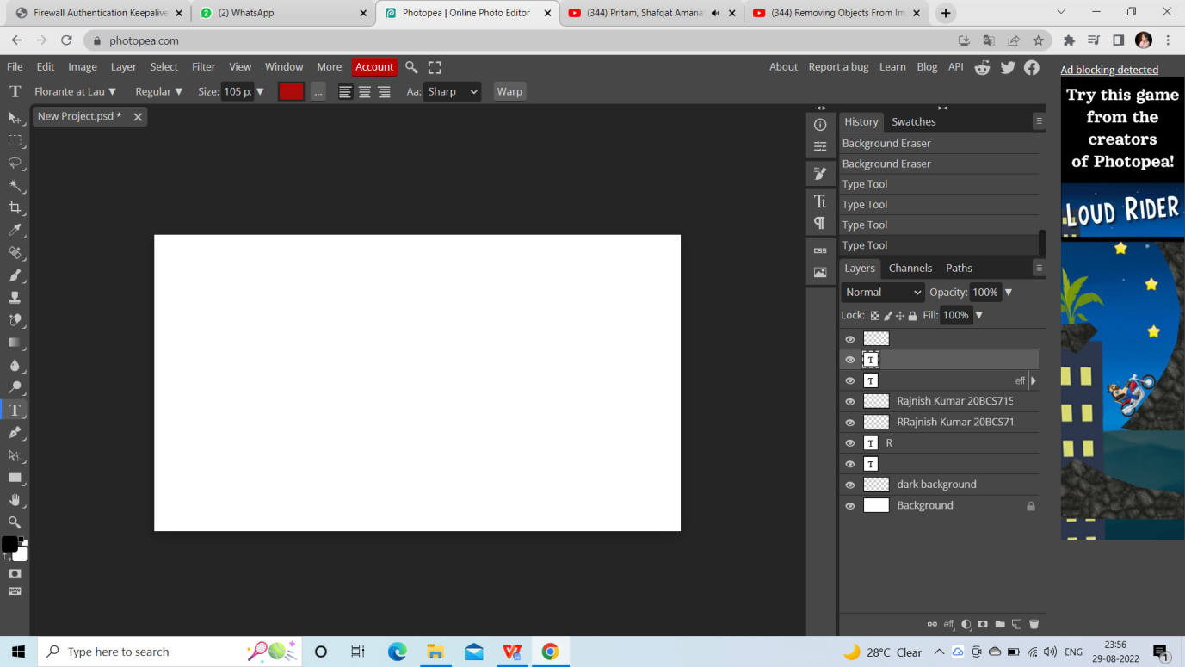

**Step 3: Select font type.**

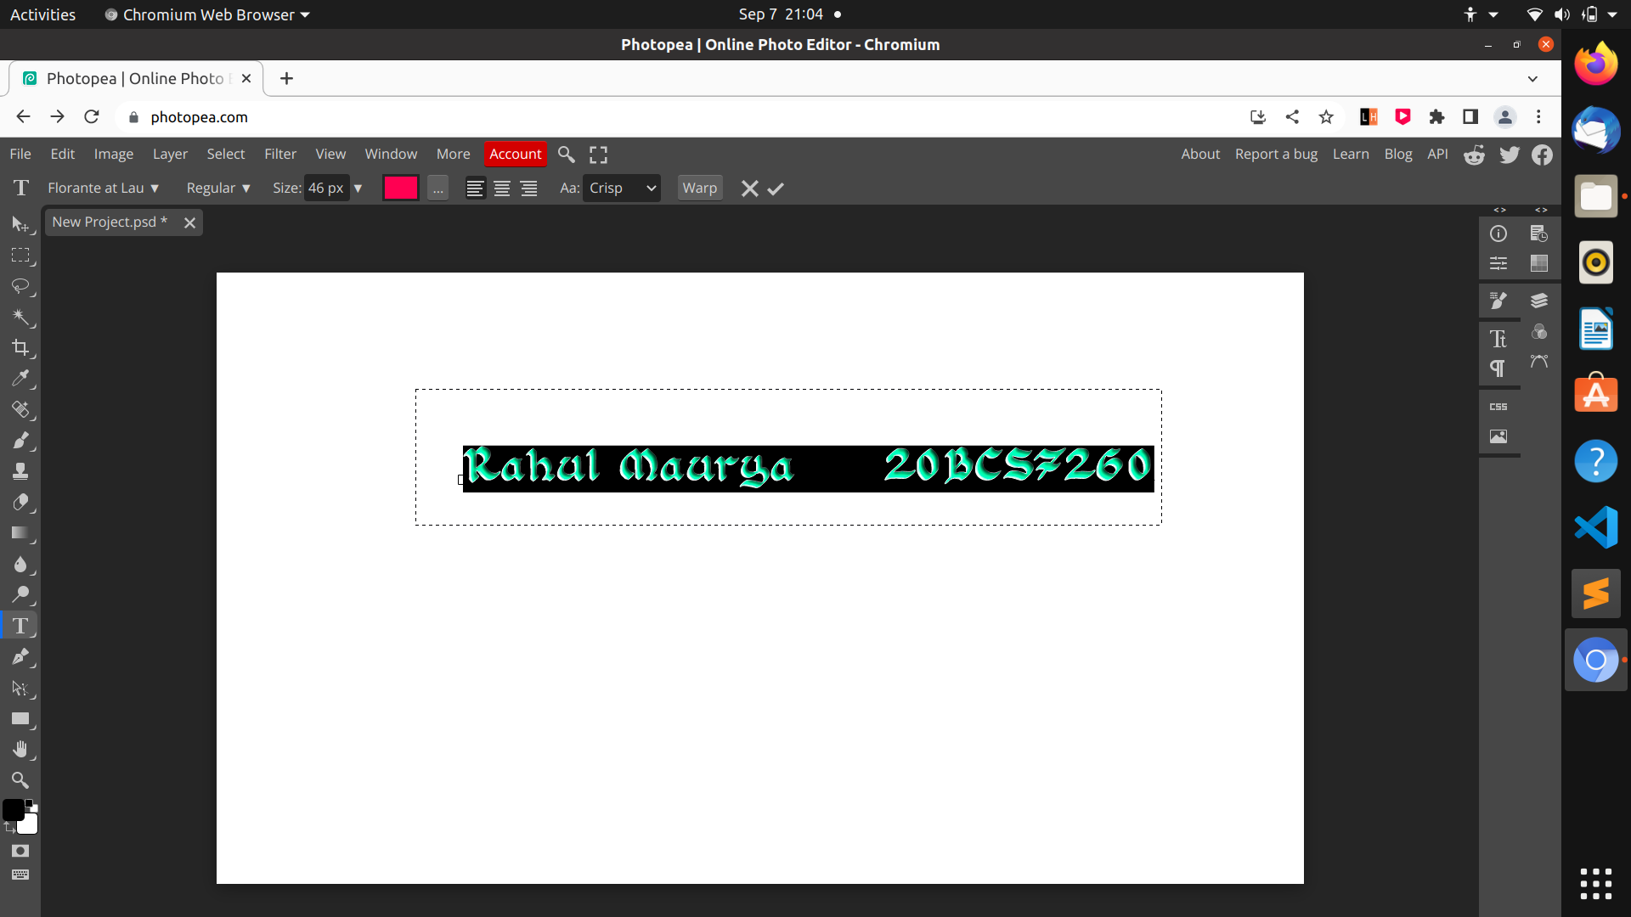

**Step 4: Select Bevel and Emboss option.**

**Step 5: Select emboss option according to requirements.**

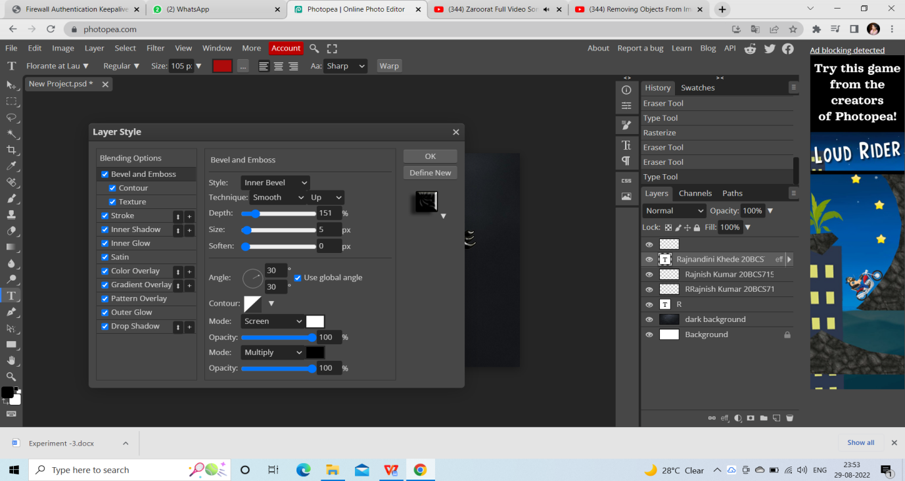

**Output:**

